# EduConnect : Smart Learning and Enrollment CRM Portal (Phase 2)

# Goal:

# The goal of this project is to build a Salesforce-based Student Enrollment and Learning Portal that automates the complete admission process. It will streamline student inquiries, course enrollments, and fee tracking while reducing manual effort and delays. Automated notifications and reminders will improve communication with students and faculty. Overall, the system will enhance efficiency, accuracy, and reporting, ensuring a smoother enrollment experience for educational institutes.

# Problem Statement:

# Educational institutes face challenges in managing student inquiries, admissions, and course enrollments due to manual processes. This causes delays, missed follow-ups, and inefficiency. A Salesforce-based portal will automate lead capture, admissions, fee tracking, and notifications, ensuring faster enrollment and better reporting.

# Phase 2: Org Setup & Configuration

Phase 2 focuses on the initial Salesforce Organization setup and configuration. In this phase, the Salesforce Developer Org was set up, and core administrative configurations were made to establish a secure and structured environment for the Smart Student Enrollment and Learning Portal.

## Org Setup

* Created and configured a Salesforce Developer Org.
* Set up the company profile including organization name.
* Set up the fiscal year.
* Set up the business hours and Holidays.
* Defined operating parameters to align with the educational institute’s requirements.

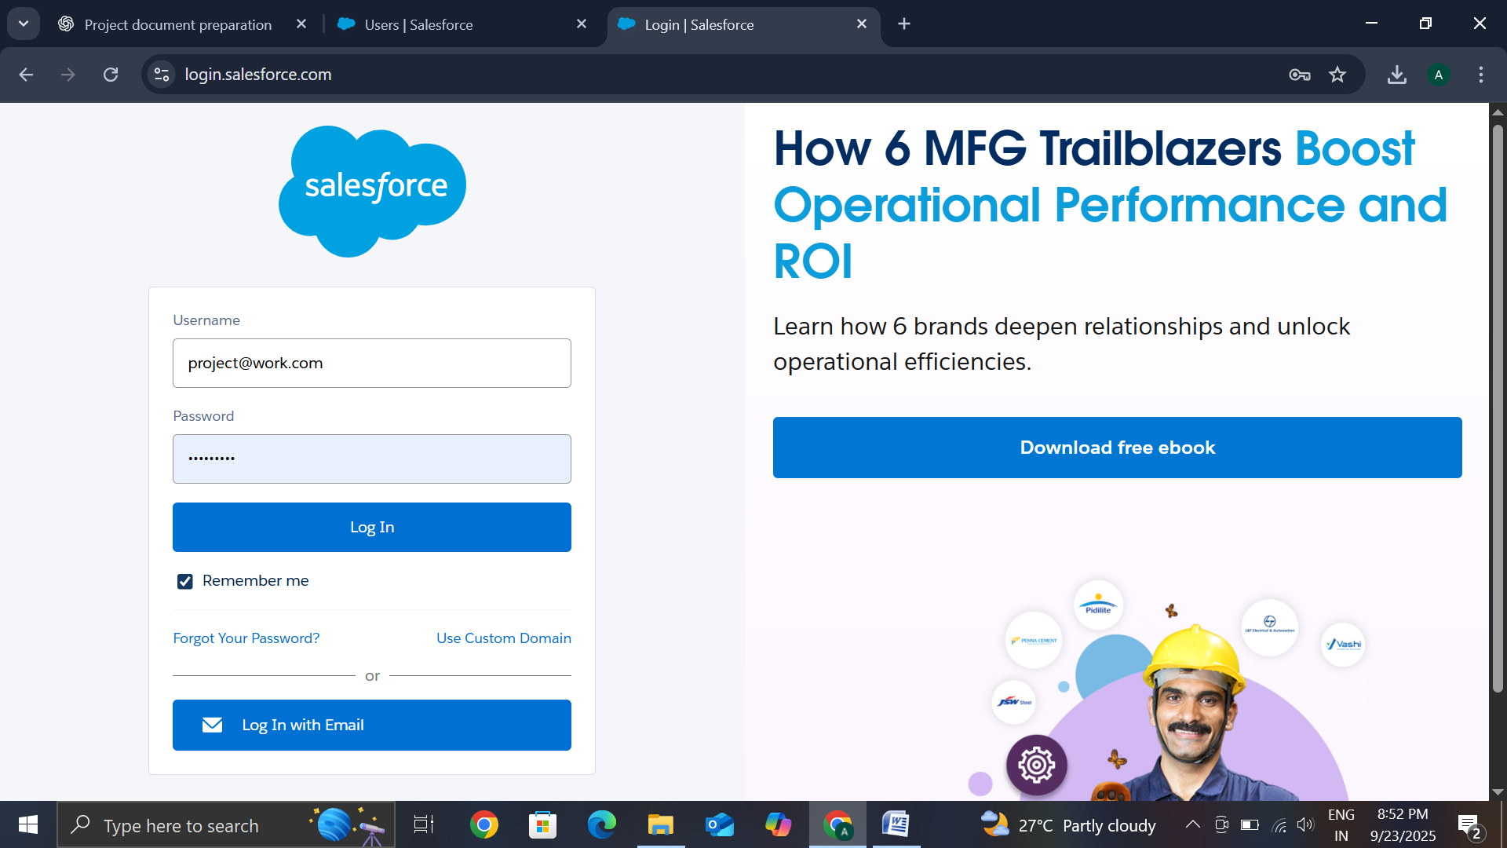

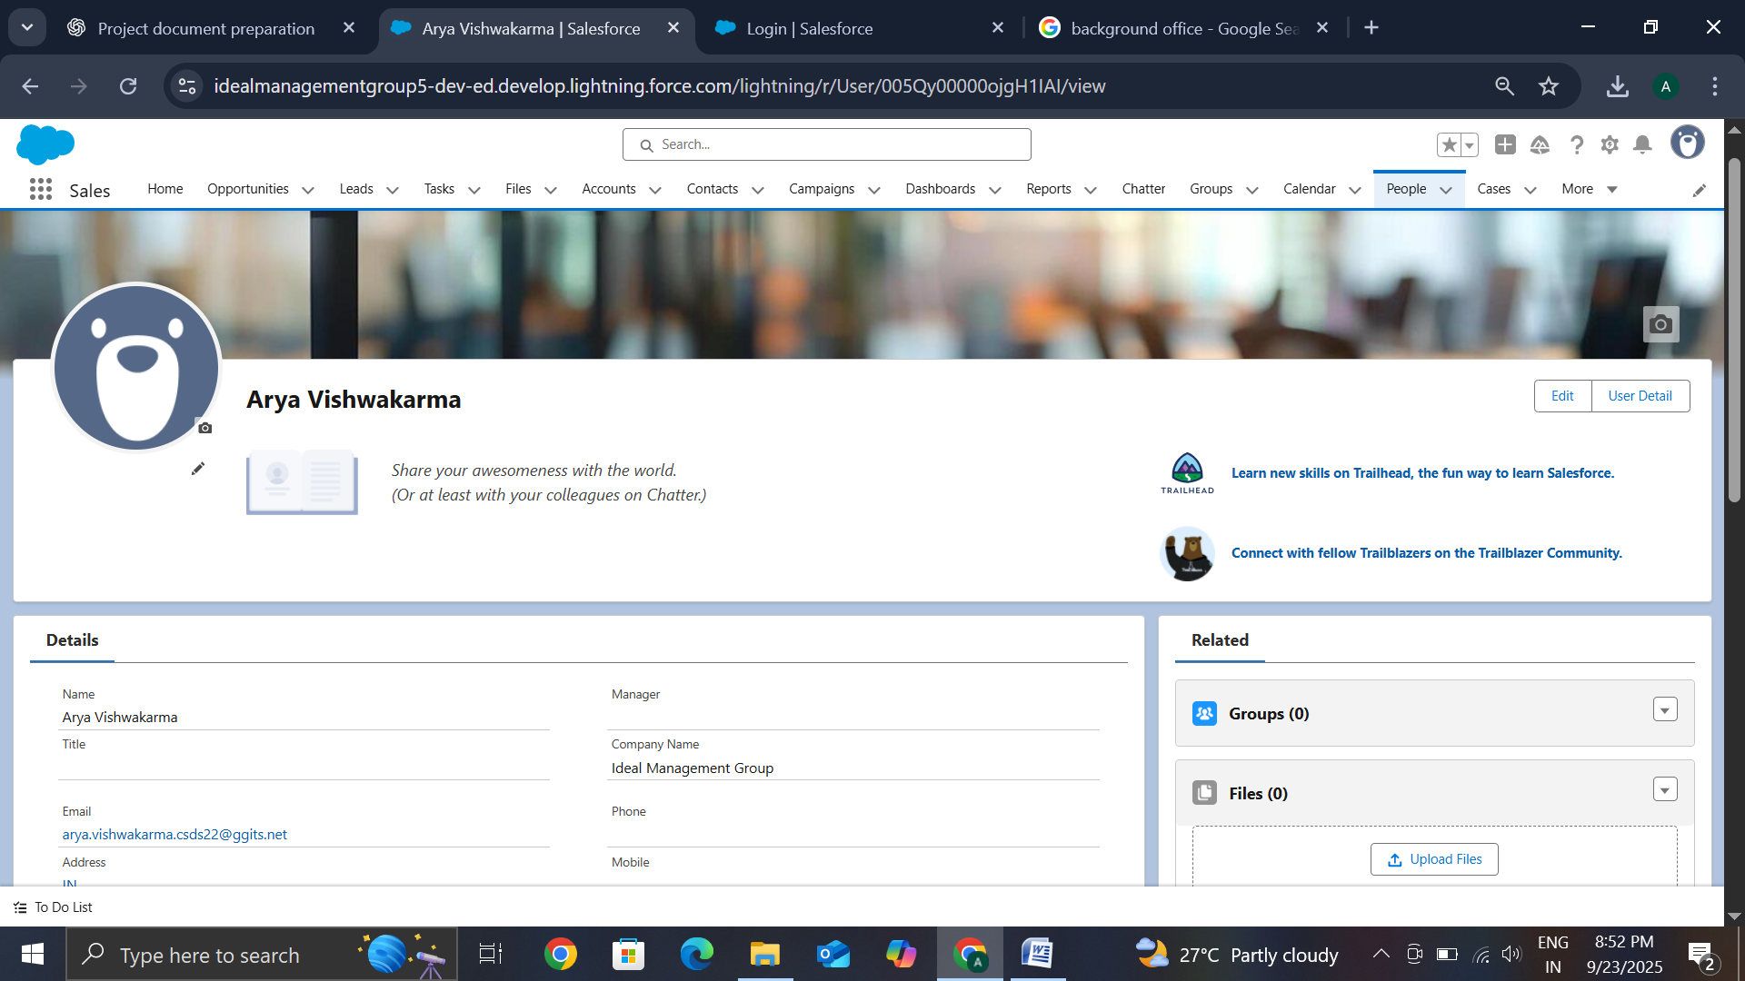

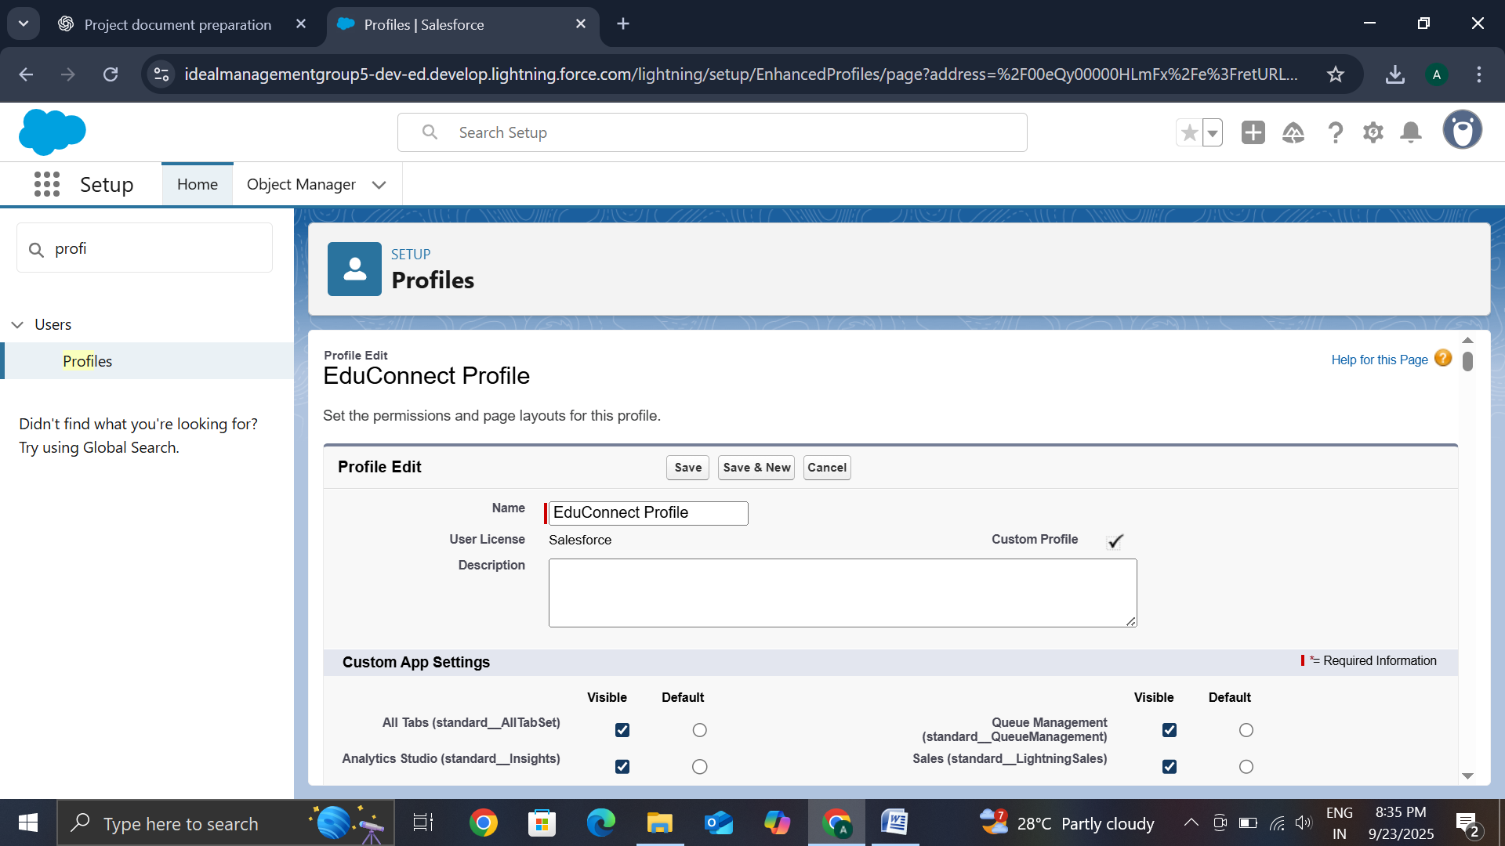

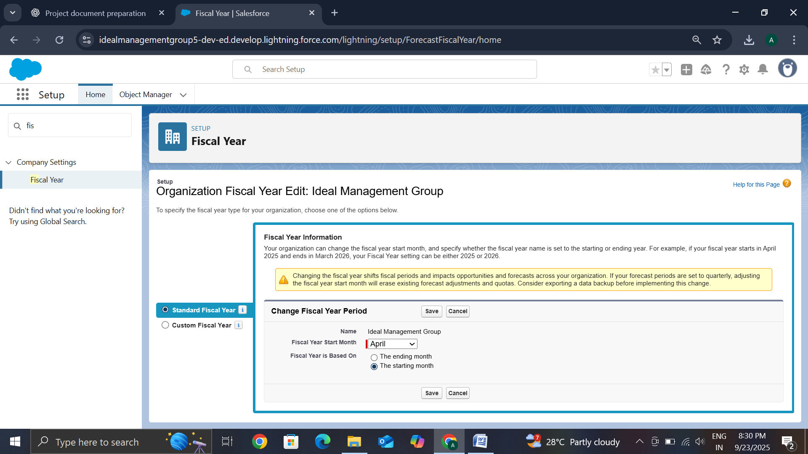

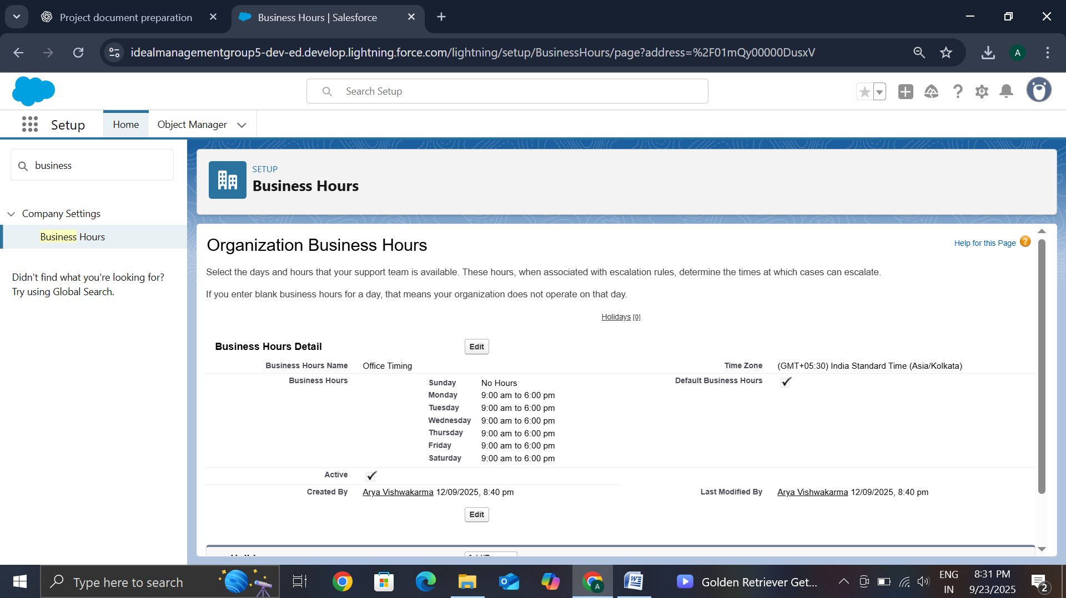

## Conclusion

Phase 2 successfully completed the setup of the Salesforce Org environment. By configuring company settings, user management, and security controls, a secure and structured foundation was established to support subsequent phases of the Smart Student Enrollment and Learning Portal project.